Simple forecast 10 periods

Simple forecast 30 periods

Feature Importance

Metrics

Adding company holiday (exogenous variable) as 1/0 (True/false does not work – generates negative prediction)

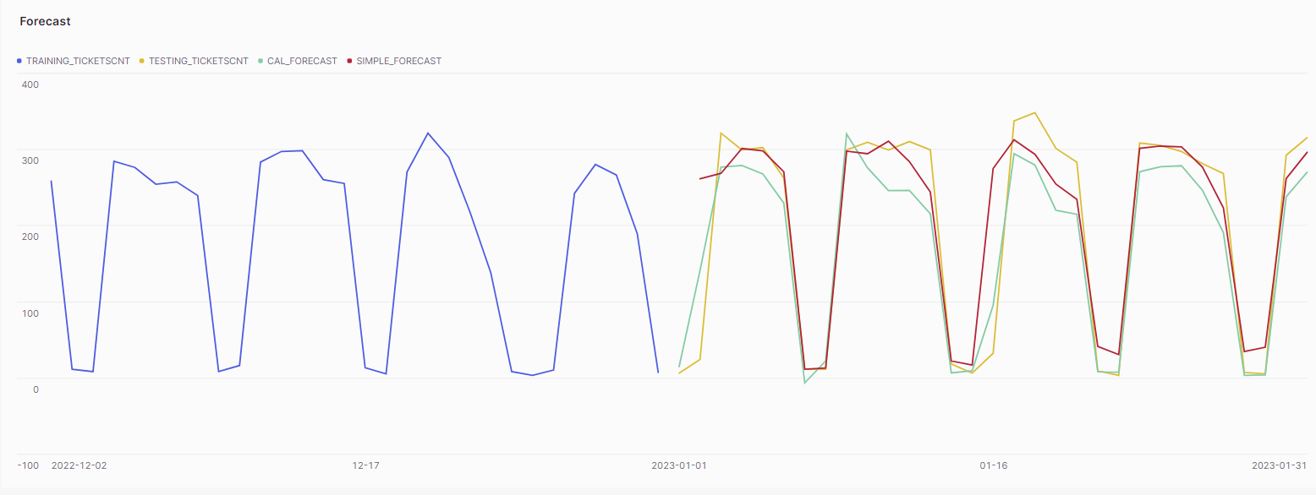

Feature Importance – holiday is not very important

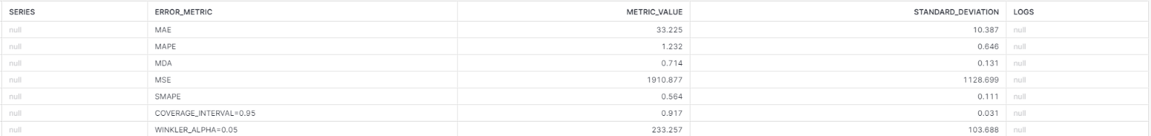

Customer Service Queue 1 series forecast (negative predictions)

Customer Service Queue 2

All other groups

Feature Importance by Group

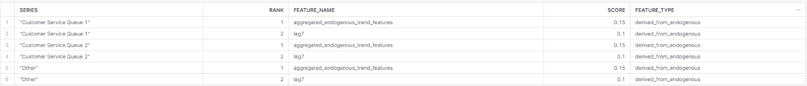

Metrics

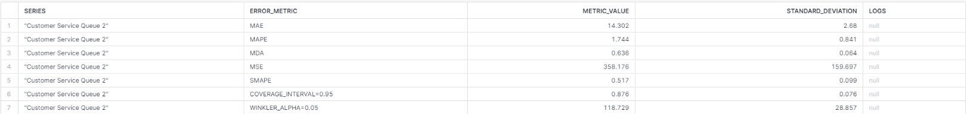

Anomaly Detections by group

Other

Customer Service Queue 1

Customer Service Queue 2

Feature Importance

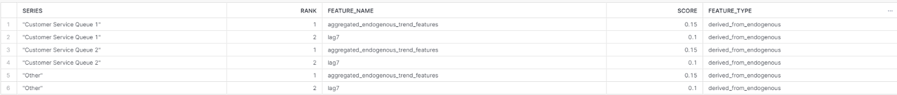

Metrics

